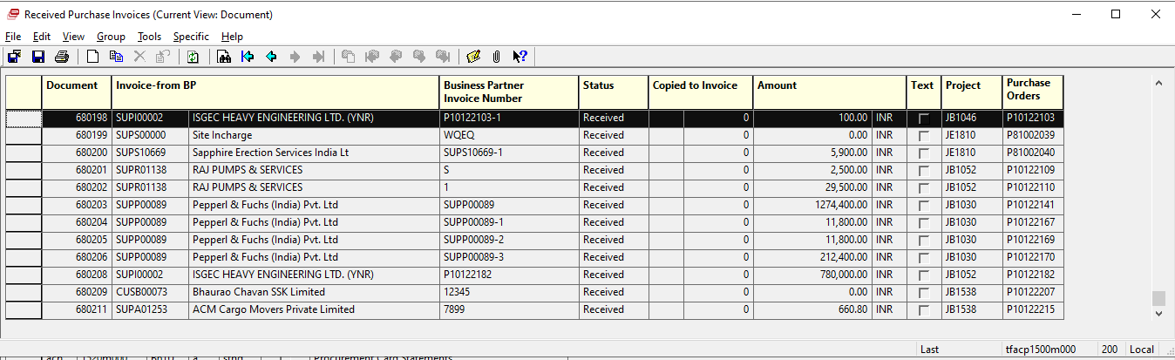

Project field and Purchase Order are shown in tfacp1500m000